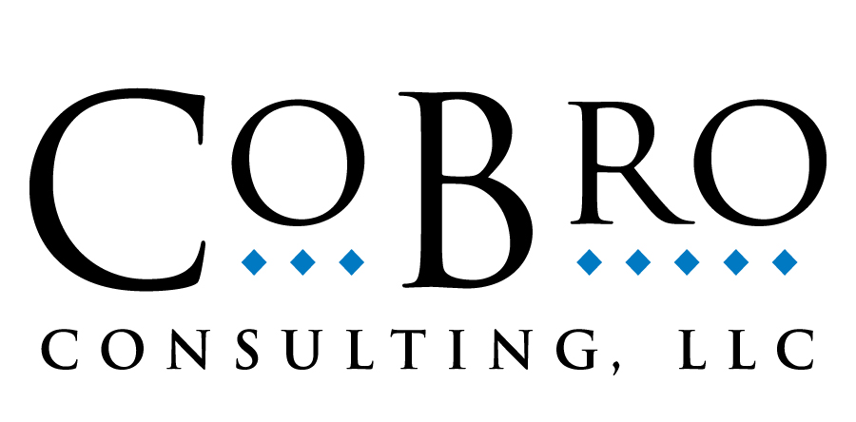

CoBro Consulting Services CompassMatch Customization Form

Please complete the following information so that we may customize the CompassMatch system for your program. When you are finished completing this form, please save the document and email it as an attachment to upelicon@CoBroConsulting.com. Thank you for your interest in our evaluation systems and services!

Main Contact Information for CompassMatch
Name: Title:
Program Name:
Phone: Email:
State Mileage Reimbursement Rate:

Partner Information
Please list all program partners and, if offered, their documented percent contribution for staff benefits (if your program currently has more than six partners, an electronic file of this information may also be provided).
Partner Company/Institution Name: % Benefits:

Program and Staff Information
Please list the person(s) identified as CompassMatch Administrator (this is normally the program fiscal representative) and their corresponding email addresses.
System Administrator Name Email Address:

Please provide an electronic file listing (Word or Excel) of the names of all personnel who will use or enter match into the system, along with their corresponding partner company/institution name, current salary (please note if amount is hourly, monthly, or annual), benefit percentage, hours worked annually and email address. Note that, if a complete listing of all users is not available at this time, information for additional users may be added manually once the system is live.

Thank you for providing the above information. We appreciate your prompt response. Please send this completed questionnaire to upelicon@CoBroConsulting.com

